#
# This network configuration via ip-commands is working!
#

[s.belogrud@TCS4357]# ssh user@10.213.40.11
user@10.213.40.11's password:
Welcome to Ubuntu 18.04.1 LTS (GNU/Linux 4.15.0-29-generic x86_64)

* Documentation: https://help.ubuntu.com
* Management: https://landscape.canonical.com
* Support: https://ubuntu.com/advantage

System information as of Wed Apr 8 10:27:15 EDT 2020

System load: 0.0 Memory usage: 0% Processes: 619
Usage of /: 0.4% of 364.28GB Swap usage: 0% Users logged in: 1

* Canonical Livepatch is available for installation.
- Reduce system reboots and improve kernel security. Activate at:
https://ubuntu.com/livepatch

0 packages can be updated.
0 updates are security updates.

Last login: Thu Apr 2 10:07:07 2020
user@ds-sage-soc-eswarm-prod01:~$ sudo -i
[sudo] password for user:
root@ds-sage-soc-eswarm-prod01:~# cat ~/work/20200406-1728/ip.sh
modprobe bonding
ip link add bond0 type bond
ip link set bond0 type bond miimon 100 mode 802.3ad lacp_rate fast xmit_hash_policy layer2+3
ip link set eno5 master bond0
ip link set eno6 master bond0
ip link set bond0 up
ip link add link bond0 name bond0.1340 type vlan id 1340
ip address add 10.213.40.11/24 dev bond0.1340
ip link set bond0.1340 up
ip route add default via 10.213.40.254 dev bond0.1340
ip -f inet addr
root@ds-sage-soc-eswarm-prod01:~#

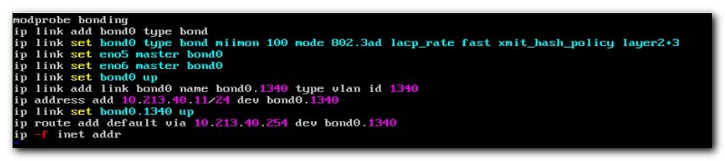

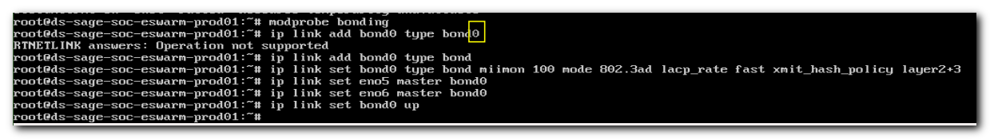

# I cannot define default route before I up the interface, used to access to default gateway.
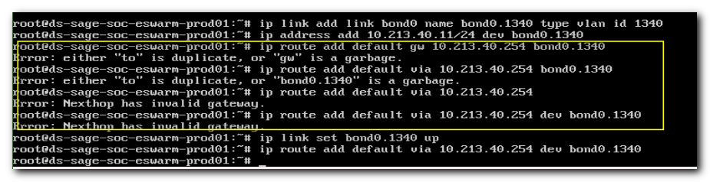

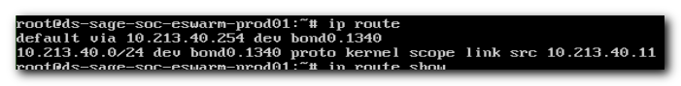
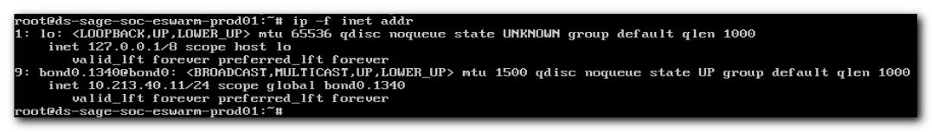
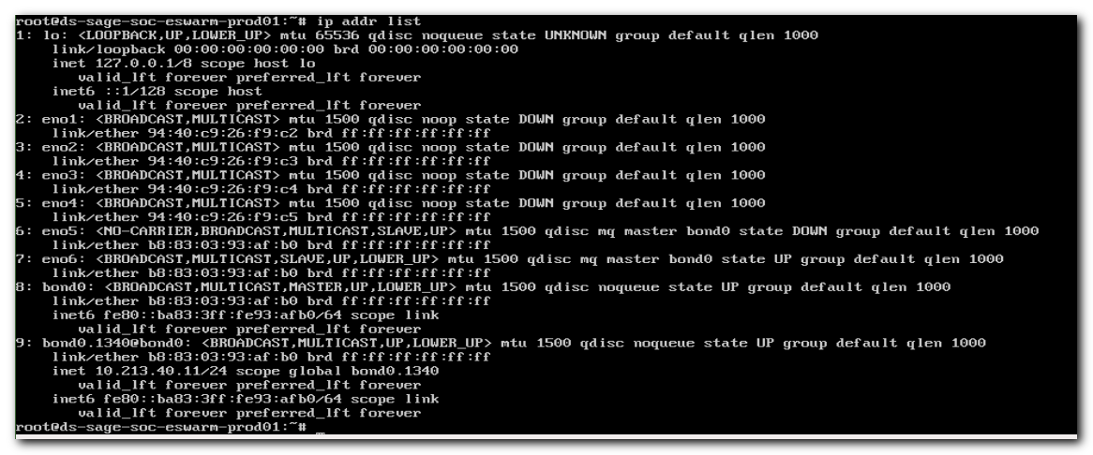
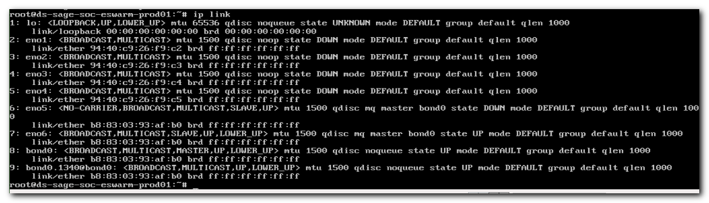
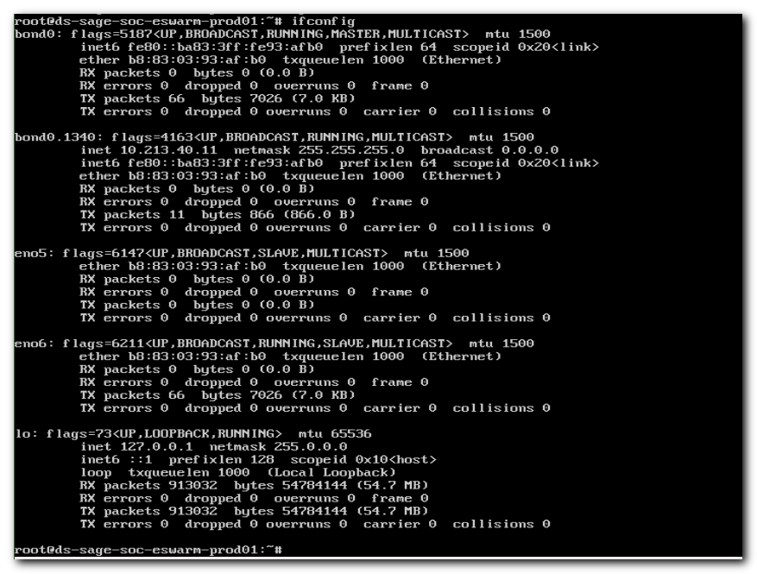
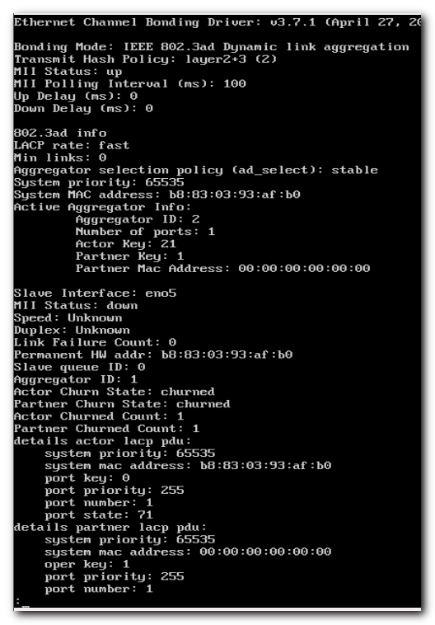
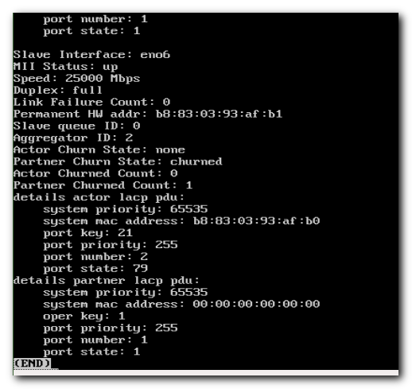

https://access.redhat.com/documentation/en-us/red_hat_enterprise_linux/7/html/networking_guide/sec-vlan_on_bond_and_bridge_using_ip_commands

10.6. VLAN ON BOND AND BRIDGE USING IP COMMANDS
To use VLANs over bonds and bridges, proceed as follows:
Add a bond device as root:
# ip link add bond0 type bond
# ip link set bond0 type bond miimon 100 mode active-backup
# ip link set em1 down
# ip link set em1 master bond0
# ip link set em2 down
# ip link set em2 master bond0
# ip link set bond0 up

Set VLAN on the bond device:
# ip link add link bond0 name bond0.2 type vlan id 2
- # ip link set bond0.2 up

https://access.redhat.com/documentation/en-us/red_hat_enterprise_linux/7/html/networking_guide/sec-configuring_static_routes_with_ip_commands

4.4. CONFIGURING STATIC ROUTES WITH IP COMMANDS
As a system administrator, you can configure static routes using the ip route command.
To display the IP routing table, use the ip route command. For example:
~]$ ip route
default via 192.168.122.1 dev ens9 proto static metric 1024
192.168.122.0/24 dev ens9 proto kernel scope link src 192.168.122.107
192.168.122.0/24 dev enp1s0 proto kernel scope link src 192.168.122.126
The ip route commands take the following form:
ip route [ add | del | change | append | replace ] destination-address
See the ip-route(8) man page for more details on the options and formats.
To add a static route to a host address, in other words to a single IP address:
~]# ip route add 192.0.2.1 via 10.0.0.1 [dev interface]
where 192.0.2.1 is the IP address of the host in dotted decimal notation, 10.0.0.1 is the next hop address and interface is the exit interface leading to the next hop.
To add a static route to a network, in other words to an IP address representing a range of IP addresses:
~]# ip route add 192.0.2.0/24 via 10.0.0.1 [dev interface]
where 192.0.2.0 is the IP address of the destination network in dotted decimal notation and /24 is the network prefix. The network prefix is the number of enabled bits in the subnet mask. This format of network address slash network prefix length is sometimes referred to as classless inter-domain routing (CIDR) notation.
To remove the assigned static route:
~]# ip route del 192.0.2.1
Any changes that you make to the routing table using ip route do not persist across system reboots. To permanently configure static routes, you can configure them by creating a route-interface file in the /etc/sysconfig/network-scripts/ directory for the interface. For example, static routes for the enp1s0 interface would be stored in the /etc/sysconfig/network-scripts/route-enp1s0 file. Any changes that you make to a route-interface file do not take effect until you restart either the network service or the interface. The route-interface file has two formats:
- ip command arguments, see the section called “Static Routes Using the IP Command Arguments Format”.
and
- network/netmask directives, see the section called “Static Routes Using the Network/Netmask Directives Format”.
See the ip-route(8) man page for more information on the ip route command.

https://access.redhat.com/documentation/en-us/red_hat_enterprise_linux/7/html/networking_guide/sec-configuring_ip_networking_with_ip_commands

3.6. CONFIGURING IP NETWORKING WITH IP COMMANDS
As a system administrator, you can configure a network interface using the ip command, but but changes are not persistent across reboots; when you reboot, you will lose any changes.
The commands for the ip utility, sometimes referred to as iproute2 after the upstream package name, are documented in the man ip(8) page. The package name in Red Hat Enterprise Linux 7 is iproute. If necessary, you can check that the ip utility is installed by checking its version number as follows:
~]$ ip -V
ip utility, iproute2-ss130716
The ip commands can be used to add and remove addresses and routes to interfaces in parallel with NetworkManager, which will preserve them and recognize them in nmcli, nmtui, control-center, and the D-Bus API.
To bring an interface down:
ip link set ifname down
Note
The ip link set ifname command sets a network interface in IFF_UP state and enables it from the kernel's scope. This is different from the ifup ifname command for initscripts or NetworkManager's activation state of a device. In fact, NetworkManager always sets an interface up even if it is currently disconnected. Disconnecting the device through the nmcli tool, does not remove the IFF_UP flag. In this way, NetworkManager gets notifications about the carrier state.
Note that the ip utility replaces the ifconfig utility because the net-tools package (which provides ifconfig) does not support InfiniBand addresses.
For information about available OBJECTs, use the ip help command. For example: ip link help and ip addr help.
Note
ip commands given on the command line will not persist after a system restart. Where persistence is required, make use of configuration files (ifcfg files) or add the commands to a script.
Examples of using the command line and configuration files for each task are included after nmtui and nmcli examples but before explaining the use of one of the graphical user interfaces to NetworkManager, namely, control-center and nm-connection-editor.
The ip utility can be used to assign IP addresses to an interface with the following form:
ip addr [ add | del ] address dev ifname

Assigning a Static Address Using ip Commands
To assign an IP address to an interface:
~]# ip address add 10.0.0.3/24 dev enp1s0
You can view the address assignment of a specific device:
~]# ip addr show dev enp1s0
2: enp1s0: <BROADCAST,MULTICAST,UP,LOWER_UP> mtu 1500 qdisc pfifo_fast state UP qlen 1000
link/ether f0:de:f1:7b:6e:5f brd ff:ff:ff:ff:ff:ff
inet 10.0.0.3/24 brd 10.0.0.255 scope global global enp1s0
valid_lft 58682sec preferred_lft 58682sec
inet6 fe80::f2de:f1ff:fe7b:6e5f/64 scope link
valid_lft forever preferred_lft forever
Further examples and command options can be found in the ip-address(8) manual page.

Configuring Multiple Addresses Using ip Commands
As the ip utility supports assigning multiple addresses to the same interface it is no longer necessary to use the alias interface method of binding multiple addresses to the same interface. The ip command to assign an address can be repeated multiple times in order to assign multiple address. For example:
~]# ip address add 192.168.2.223/24 dev enp1s0
~]# ip address add 192.168.4.223/24 dev enp1s0
~]# ip addr
3: enp1s0: <BROADCAST,MULTICAST,UP,LOWER_UP> mtu 1500 qdisc pfifo_fast state UP qlen 1000
link/ether 52:54:00:fb:77:9e brd ff:ff:ff:ff:ff:ff
inet 192.168.2.223/24 scope global enp1s0
inet 192.168.4.223/24 scope global enp1s0
For more details on the commands for the ip utility, see the ip(8) manual page.
Note
ip commands given on the command line will not persist after a system restart.

https://www.tecmint.com/configure-network-bonding-teaming-in-ubuntu/

To use network bonding mechanism in Ubuntu or Debian based Linux systems, first you need to install the bonding kernel module and test if the bonding driver is loaded via modprobe command.
$ sudo modprobe bonding

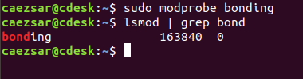
Check Network Bonding in Ubuntu
On older releases of Debian or Ubuntu you should install ifenslave package by issuing the below command.
$ sudo apt-get install ifenslave

Next use mii-tool tool to check Network Interface Controller (NIC) parameters as shown.
$ mii-tool

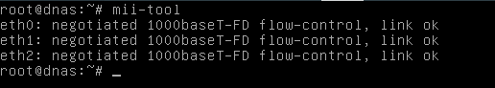

The types of Network Bonding are listed below.

mode=0 (balance-rr)
mode=1 (active-backup)
mode=2 (balance-xor)
mode=3 (broadcast)
mode=4 (802.3ad)
mode=5 (balance-tlb)
mode=6 (balance-alb)
The full documentations regarding NIC bonding can be found at Linux kernel doc pages.

#
# After server become awailable via ssh.
#
root@ds-sage-soc-eswarm-prod01:~# ifup

Command 'ifup' not found, but can be installed with:

apt install ifupdown
apt install ifupdown2
apt install netscript-2.4

root@ds-sage-soc-eswarm-prod01:~#

